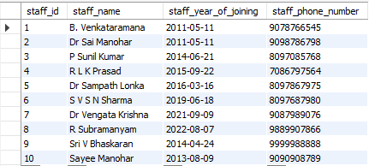

**Normalizing staff_table**

*By default my table is in 1NF because each record is unique & also each cell contains a single value.*

*Now checking whether my table is in 2 NF or not.*

1. *It is 1 NF form.*
2. *There is a* **Primary Key** *that does not functionally dependant on any subset of candidate key relation.*
3. *In my table staff_id is the* **PRIMARY KEY.**
4. *The Functional Dependencies in my table are FD={staff_id → staff_name, staff_id → staff_year_of_joining, staff_id →staff_phone_number}.*
5. *The prime attribute is staff_id.*
6. *The non-prime attributes are staff_name,staff_year_of_joining,staff_phone_number.*
7. *FD={staff_id → staff_name, staff_id → staff_year_of_joining, staff_id →staff_phone_number}.*
8. *The non-prime attributes are partially dependent on the primary key.*

*Checking Whether staff_id table is in 3 NF or not:*

*As there are no transitive functional dependencies, and hence our table is in 3 NF.*